**IT8701 Introduction to Programming for Data Science**

**What you will learn / do in this lab**

1. Perform input and output
2. Work with basic data types like integers, floats and strings
3. Use assignment, arithmetic, comparison and logical operators
4. Write if/else statements in Python
5. Write for/ while loops in Python
6. Write Python functions
7. Use Python lists

**Table of Contents**

1. Overview 3

A. What you will do for this lab 3

B. Intro to Python 3

2. Inputs, Outputs and Variables in Python 4

Task 1: Basic Inputs and Outputs in Python 4

Task 2: Converting numeric inputs 4

Task 3: Formatting outputs 4

Task 4: Average of electricity bills (SUBMISSION REQUIRED) 5

3. Using import in Python 6

Task 1: Timer 6

Task 2: Reaction game 7

Task 3: Days before assignment is due 7

4. Working with Python numeric types 9

Task 1: Perform basic mathematical calculations 9

Task 2: Mathematical functions in Python 10

5. Working with Python string types 11

Task 1: Perform simple string operations 11

Task 2: Perform simple string operations (SUBMISSION REQUIRED) 12

6. if-else statements 13

Task 1: Odd or even 13

Task 2: Spdonalds (SUBMISSION REQUIRED) 14

7. for loop 15

Task 1: Repeat a user-specified message 15

Task 2: Calculate sum of numbers within a range (SUBMISSION REQUIRED) 15

8. while loop 17

Task 1: Count down timer 17

Task 2: High-low number game 17

9. Python Lists 19

Task 1: Lists (Elements less than 5) 19

Task 2: Lists (max, min, sorted, reverse) 19

Task 3: List Slicing 20

Task 4: BMI 20

10. Python functions 22

Task 1: Scissors, Paper, Stone 22

Task 2: Odd and Even (SUBMISSION REQUIRED) 23

11. Python Input/Output 24

Task 1: Read file 24

Task 2: Read data file from data.gov.sg 24

# Overview

## What you will do for this lab

In this lab, you will learn how to write a few simple Python programs to get your familiar with the syntax of the Python programming language.

You will **NOT** be learning any data science-specific Python commands yet. Those will be featured in later topics, so please wait patiently for them 😊

## Intro to Python

Python has become one of the de facto standard language and platform for data analysis and data science.

Python is a very versatile programming language that that you can do many things with, from performing simple mathematical operations to data visualization and even machine learning and predictive analytics.

Regardless of the task at hand, make sure you are familiar with the basics concepts of the Python programming language first before delving into the more complicated stuffs!

|  |  |
| --- | --- |
| **Python can be used to perform simple mathematical operations like this one.** | **Python can also be used to plot complex visualizations like this one.** |
| |  | | --- | | x = 5  y = 3  z = x*y + y/x | | image |

# Inputs, Outputs and Variables in Python

### Task 1: Basic Inputs and Outputs in Python

Write a Python program that prompts the user for his name, and outputs a greeting to him with his name as shown in the figure below.

|  |
| --- |
|  |

### Task 2: Converting numeric inputs

Write a Python program that prompts the user to enter the length of a square and prints out the area and perimeter of the square as shown in the figure below.

Hint -- > Remember to convert your inputs to datatype int or float before performing calculations!

|  |
| --- |
|  |

### Task 3: Formatting outputs

Write a Python program that prompts the user to enter his height and weight, then calculates his BMI to a precision of 1 decimal place as shown in the figure below.

Hint -- > Remember to convert your inputs to datatype float before performing calculations!

|  |
| --- |
|  |

### Task 4: Average of electricity bills (SUBMISSION REQUIRED)

Write a Python program that prompts the user to enter his electricity bill for the last 6 months and prints out the average of his electricity bills as shown below.

Hint -- > Remember to convert your inputs to datatype float before performing calculations!

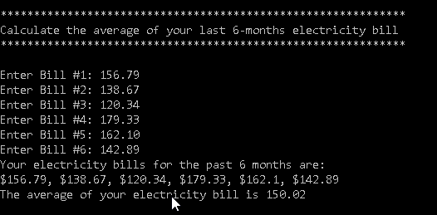

# Using import in Python

As mentioned earlier, Python programs can do *almost* anything.

Why is Python is so “powerful”?

The reason is simple – there are many other Python programmers out there, and they have written a lot of Python code which you can just re-use by “importing” their code, also known as “modules” into your own Python program.

In this section, you will learn how to import Python modules that can help you complete certain tasks you may need to do.

For example, you may need your Python program to wait for 2 seconds before executing the next action. In that case, you can import the ***time*** module, which will allow you to make your Python programme “sleep” for a specified number of seconds.

Perhaps you need to generate a list of 10 random numbers in the range of 1 to 100. To do that, you can import the ***random*** module, which will allow you to generate random numbers of your preferred range.

### Task 1: Timer

Write a Python program that acts like a count-down timer.

Your program should:

1. prompt the user to enter the number of seconds he wishes to count down and store it in a variable called *time_to_wait*
2. use the sleep function to wait for the specified number of seconds
3. display a message “Time is up!” when the specified number of seconds has elapsed

|  |
| --- |
|  |

### Task 2: Reaction game

Write a Python ‘game’ that tests how fast a user can respond.

Your program should:

1. store the current time in a variable *time_now*
2. Prompt the user with a message “Timer starts now! Press any key as quickly as possible!” and wait for the user to key in his input in a variable called *user_input*
3. Record and store the time at which the user’s input was captured in a variable *time_entered*
4. Calculate the time that has elapsed between time_now and time_entered, which is the time the user took to respond. Store this in a variable *time_response*
5. Display *time_response* to the user as shown in the diagram below

|  |
| --- |
|  |

### Task 3: Days before assignment is due

Write a Python program that prompts the user for the due date of an assignment, then calculates the number of days till the due date of the assignment from the current date.

Your program should:

1. store the current date in a variable date_today
2. Prompt the user with a message “Please enter the due date of the assignment”
3. Store the user’s input in a variable named assignment_duedate
4. Calculate the number of months and days between date_today and assignment_duedate, and store the result in the variable number_of_monthsand number_of_days
5. Display the result to the user as shown in the diagram below

Hint: Refer to **Using import (5) example in Powerpoint slides**

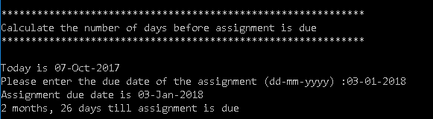

# Working with Python numeric types

### Task 1: Perform basic mathematical calculations

Write a Python program that performs the fundamental operations in mathematics: addition, subtraction, multiplication and division.

Your program should:

1. prompt the user to enter four numbers and store them in the variables *n1*,*n2*,*n3* and *n4*
2. add up the four numbers and store the calculated value in the variable *add*
3. subtract *n4* from *n1* and store the calculated value in the variable *difference*
4. multiply *n2* by *n3* and store the calculated value in the variable *product*
5. divide the sum of *n1* and *n2* by the sum of *n3* and *n4*, and store the calculated value in the variable *quotient*
6. find the remainder of the product of *n1* and *n2*, divided by the product of *n3* and *n4* and store in the value *remainder*
7. calculate *n1* to the power of n2 and store in the variable *powerI*
8. print out the outputs as shown in the diagram below

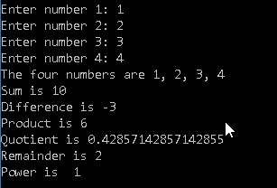

### Task 2: Mathematical functions in Python

Write a Python program that performs uses mathematical functions in Python like sqrt, factorial, ceil, floor and so on.

Your program should:

1. prompt the user to enter four numbers and store them in the variables n1,n2,n3 and n4
2. Perform the following operations on each variable as specified below.
3. Calculate the square root of n1 and store the value of the result to a variable n1_squareroot. Print out the **ceiling** value of n1_squareroot.
4. Multiply n2 by the mathematical value of **pi** and store the result to a variable n2_times_pi. . Print out the **truncated** value of n2_times_pi.
5. Calculate the value of n3 to the power of n1 and store the result to n3_powerof_n1. Print out the **floor** value of n3_powerof_n1.
6. Compute the factorial of n4 and store the result to a variable n4_factorial. Divide n4_factorial by n3 and store the result to n4n3. Compute the fractional and integer parts of n4n3 and print out their values.

Hint -- > Remember to convert your inputs to datatype float before performing calculations!

Your program should produce outputs similar to that below.

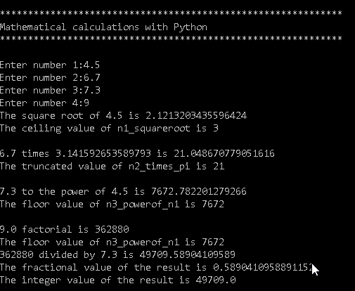

# Working with Python string types

### Task 1: Perform simple string operations

Write a Python program that performs simple string operations using the string class

Your program should:

1. prompt the user to enter three string variables and store them in s1, s2 and s3
2. print out the length of all the three strings
3. print out s1 in all capital letters
4. locate letter a in s2 and print out the index if found or print “The letter a is not found in s2” if not found
5. extract the first 2 characters from s3 and print them out

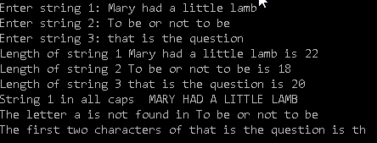

### Task 2: Perform simple string operations (SUBMISSION REQUIRED)

Write a Python program to achieve the following:

1. prompt the user to enter 3 random strings of at least 8 characters long, each separated by a comma

A sample of what the user might enter is given below

*When Breath Becomes Air,The 91-Storey Treehouse,Harry Potter and the Prisoner of Azkaban*

1. use the **split()** function in Python to separate the strings and store the separated strings into three variables, s1, s2 and s3
2. Perform the following operations on each string:

* calculate the length of each string
* extract the 2nd and third characters of s1, fifth to seven characters of s2 and last two characters of s3
* Your output should look similar to that as shown below.

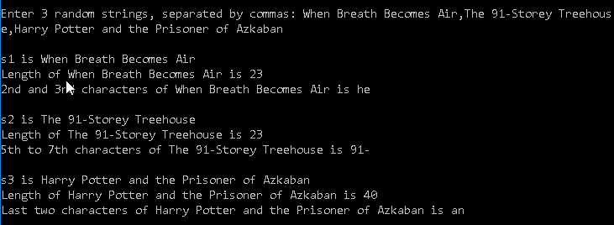

# if-else statements

### Task 1: Odd or even

Ask the user for a number. If the input is not numeric, display an error message and exit the program. Hint: use the isnumeric() function.

If the input is numeric, check if the number is even or odd and print out an appropriate message to the user. Hint: Use the % modulus operator which gives the remainder when a number x is divided by another number y.

Your program should display output similar to that below.

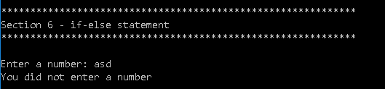

Figure 1: Error message when user entes a non-numeric input

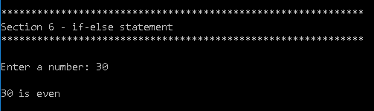

Figure 2: Message displayed when user enters a valid number that is even

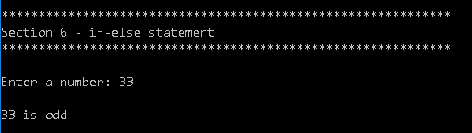

Figure 3: Message displayed when user enters a valid number that is odd

### Task 2: Spdonalds (SUBMISSION REQUIRED)

Write a Python program that displays a breakfast menu to the user, asks him for the food he wants to buy and calculates the amount he must pay for the food

Your program should:

1. show the user a menu consisting of the breakfast menu choices as shown in Fig. 1+2
2. prompt the user to enter his breakfast choice
3. Display and error message and terminate the program if the choice is invalid
4. If breakfast choice is valid, prompt him to enter the quantity he wants to buy
5. calculate and display the total amount he must pay

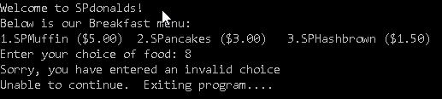

Figure 4: Invalid input

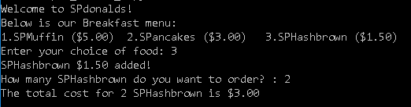

Figure 5: Valid input

# for loop

### Task 1: Repeat a user-specified message

Write a program that will ask the user for a message and the number of times they want that message displayed. Then output the message that number of times.

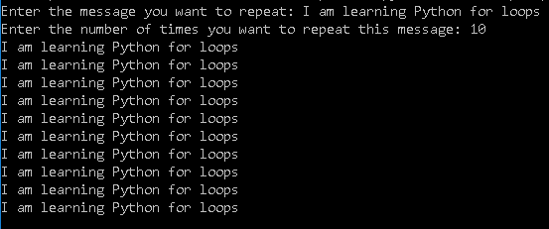

### Task 2: Calculate sum of numbers within a range (SUBMISSION REQUIRED)

Write a Python program that calculates the sum of all the numbers from x to y, where x and y are numbers entered by the user.

Your program should:

1. Inform the user the purpose of the program as shown in the screenshot below
2. Prompt the user to enter the value for x and y.
3. check if 1) x and y are numeric 2) higher than zero 3) y is greater than x. If not, display an error message and terminate the program.
4. Use a **for** loop to calculate the sum of numbers from x to y and store the final value in the variable sum_of_numbers
5. display sum_of_numbers to the user

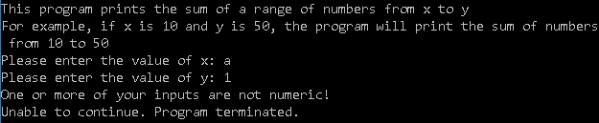

Figure 6: User did not enter numbers for x and y

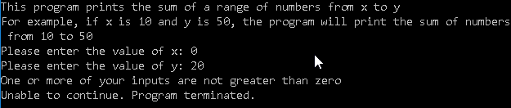

Figure 7: User did not enter numbers greater than zero for x and y

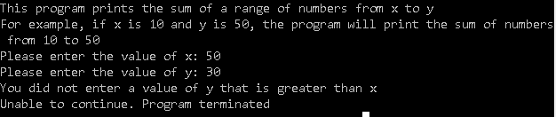

Figure 8: User did not enter y greater than x

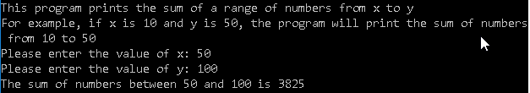

Figure 9: Print sum of numbers to user

# while loop

### Task 1: Count down timer

Create a program using **while** loop which will prompt the user to enter the number of seconds he wishes to count down, then indicate how long there is to go before time runs outs. When time runs out it should display “Time is up!”

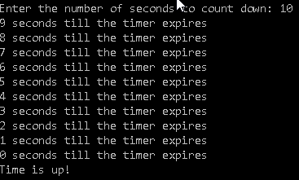

### Task 2: High-low number game

Write a Python ‘game’ that generates a random number and repeatedly allows the user to guess the number by giving him hints until he gets it right.

Your program should:

* Ask the user to select the lower limit and the upper limit that the random number should be generated within
* After obtaining the lower and upper limits, generate a random number between that range, and store it in a variable named secret_number
* Write a while loop that repeatedly performs the following actions until the user guesses the random number correctly
  1. Prompt the user to guess the value of the number
  2. If his guess is higher than the actual random number, print “Too high”
  3. If his guess is lower than the actual random number, print “Too low”
  4. If his guess is equal to the random number, print “You are right!” and exit the loop

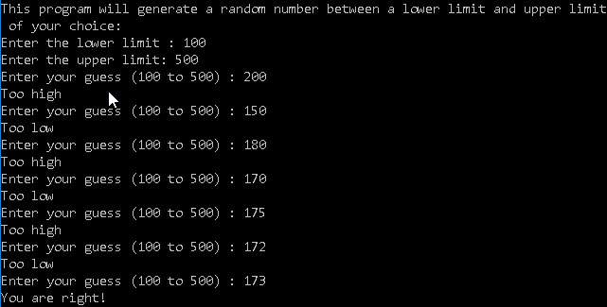

# Python Lists

### Task 1: Lists (Elements less than 5)

Given the following Python list, write a program that prints out all the elements of the list that are less than 5.

a = [1, 1, 2, 3, 5, 8, 13, 21, 34, 55, 89]

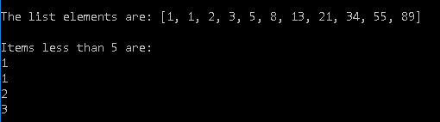

### Task 2: Lists (max, min, sorted, reverse)

Write a Python program that prompts the user to enter a list of 10 numbers and prints out the maximum and minimum values that were entered. In addition, print out the list in sorted reverse order (highest numbers first)

Your output should look similar to that below.

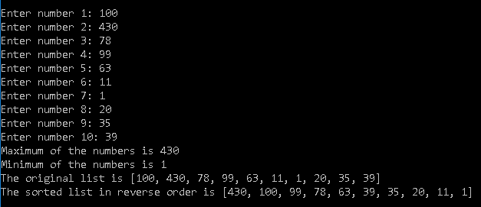

### Task 3: List Slicing

Given the three Python lists below, provide the code that will retrieve the required elements in each list.

list_1 = [300,50,80,90,199,800,74,33]

list_2 = ['Apple','Banana','Durian','Grapes','Papaya','Watermelon']

list_3 = [0.0, 1.1, 2.2, 3.3, 4.4, 5.5, 6.6, 7.7, 8.8,9.9]

1. The numbers 800, 74 and 33 in list_1
2. The last two elements in list_2
3. All the elements in list_3 except the first and the last

### Task 4: BMI

Write a Python programas follows:

Declare three Python lists at the beginning of the program with the following data

1. *list_students1* – contains names of 10 students (Ann, Brandon, Christine, Daniel, Eileen, Francis, Gloria, Henry, Irene, John)
2. *list_weights1* – contains the weights of the 10 students in kilogrammes (45,90,52,75, 48, 65, 60, 85, 49, 100)
3. *list_heights1* – contains the heights of the 10 students in metres (1.54, 1.85, 1.66, 1.75, 1.58, 1.71, 1.68, 1.78, 1.62, 1.88)
4. use a **for** loop to prompt the user to enter the names, weights and heights of 5 more students, storing the inputs into the *list_students2*, *list_weights2* and *list_heights2* variables respectively
5. combine *list_students1* and *list_students2* into a single list named *list_students_all*
6. combine *list_weights1* and *list_weights2* into a single list named *list_weights_all*
7. combine *list_heights1* and *list_heights2* into a single list named *list_heights_all*
8. use a **for** loop to calculate the BMIs of the 15 students, and store them in a list variable named *list_bmis_all*. (BMI is obtained by weight/height2)
9. print out the student with the highest BMI and lowest BMI as shown

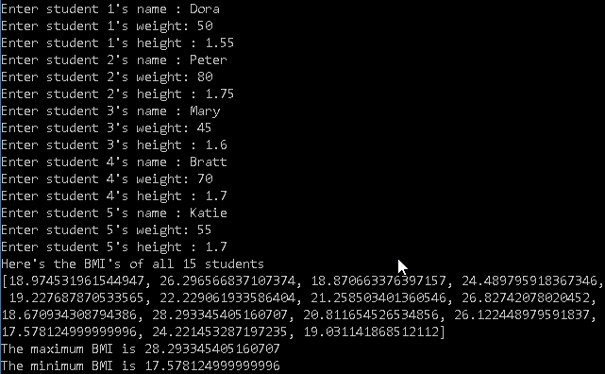

# Python functions

### Task 1: Scissors, Paper, Stone

Write a Python function **compare(input1, input2)** that takes in two string inputs which can be one of these values: Scissors, Paper or Stone. Your function should return two outputs: a message and a True or False value as follows:

|  |  |
| --- | --- |
| * If the two inputs are the same, e.g. both are “Scissors”, return “It’s a tie”, False * If input1 is “Scissors” and input2 is “Paper”, return “Scissors wins!”, False * If input1 is “Scissors” and input2 is “Stone”, return “Stone wins!”, False * If input1 is “Paper” and input2 is “Scissors”, return “Scissors wins!”, False * If input1 is “Paper” and input2 is “Stone”, return “Paper wins!”, False | * If input1 is “Stone” and input2 is “Scissors”, return “Stone wins!”, False * If input1 is “Stone” and input2 is “Paper”, return “Paper wins!”, False * If input1 is “Quit” or input2 is “Quit”, return “Quitting the program”, True * If either of input1 or input2 is not one of these values: Scissors, Paper, Stone, Quit, then return “Invalid input. Please try again”, False |

Using this function, create a Python program that simulates a two-player Scissors-Paper-Stone game that keeps repeating until any one of the user keys in a “quit” as his choice. A sample of how the program should behave is given below.

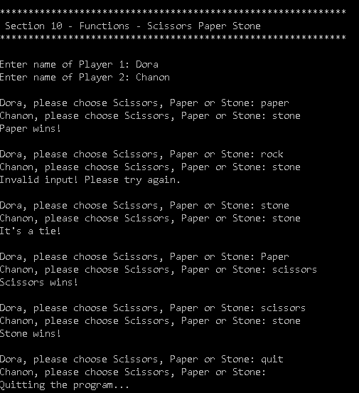

### Task 2: Odd and Even (SUBMISSION REQUIRED)

Write a Python function that takes in a list of numbers, and outputs them into two lists, one consisting of even numbers, and the other odd numbers.

Your program should:

1. Generate a list with 100 random numbers in the range of 1 to 1000 and store them in the variable original_list. Hint: You can generate a list of numbers using list comprehension and the random.randint() function

Example:

# Generate 1000 numbers from 1 to 10

numbers = [random.randint(1,10) for x in range(0,1000)]

1. Define a function called ***oddandeven(numbers_list)*** that takes in one parameter of type list containing a list of numbers and returns two outputs of two lists, one that contains even numbers, and the other that contains odd numbers
2. After writing your function, call the ***oddandeven(numbers_list)*** function, passing in original_list as the parameter, and storing the outputs of the function as even_numbers and odd_numbers respectively
3. Print out the contents of even_numbers and odd_numbers as shown in the output below

|  |
| --- |
|  |

# Python Input/Output

### Task 1: Read file

Write a Python script that takes in a series of numbers from a text file where each line of the text file contains exactly one integer.

Your script should print out some statistics regarding the file and its content.

For example, given the text file **numbers.txt** with the following contents as

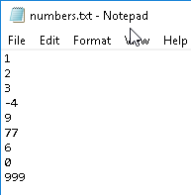

The sample output should be:

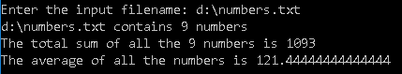

### Task 2: Read data file from data.gov.sg

Write a Python script that reads in the file from data.gov.sg at this URL:

<https://data.gov.sg/dataset/public-transport-journeys-average-distance-per-trip>

Determine the number of rows in the file, and extract the year that has the highest average_daily_passenger_journeys and the year that has the lowest average_daily_passenger_journeys.

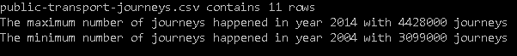



The sample output should be:



**-- End of Lab --**